Case Of Mr. Arman Khan (Ex–Chief Marketing Officer)
Employee Name: Mr. Arman Khan Designation: Chief Marketing Officer (CMO) Joining Date: January 2023
Tenure: 2 Years and 5 Months Reporting Line: Directly to the CEO Team Size Managed: 8 Employees

Introduction
When Mr. Arman Khan joined our company in January 2023, he was entrusted with a senior leadership role as Chief Marketing Officer. For over two years, he led a team of 08 employees and was directly reporting to the CEO. At the beginning, the company placed its trust in him to build, lead, and grow the marketing function.
However, towards the later stages of his tenure, his true intentions surfaced. What initially appeared as leadership gradually unfolded into lobbying, unethical practices, and actions that not only harmed the company’s internal culture but also caused severe financial and reputational damage.
The following sections narrate, in detail, how events unfolded and the impact they left behind.

The Major Case – Lobbying, Mass Resignations, and Breach of Trust
By the later stage of his tenure, Mr. Arman Khan’s performance had declined sharply. The CEO repeatedly raised concerns about missed targets, lack of seriousness, and his casual attitude. Instead of acknowledging these issues, Mr. Khan reacted with hostility. The turning point came when the CEO held a meeting with the marketing team to discuss performance gaps. Rather than responding constructively, Mr. Khan took offense and began working actively against the CEO.

Creation of the Lobby
Following this meeting, Mr. Khan began to position himself as a “leader” of his team, encouraging them to stand against the company’s management. He created a lobby within the marketing department, telling employees that he would “save them” and protect

their rights if they followed his lead. He went further, instructing them to submit resignations en masse, framing it as a way to challenge the CEO’s authority.
- Evidence: Screenshots of Mr. Khan asking employees to submit resignations are attached as Annexure A.

Shockingly, the team — most of whom he had personally hired, often through biased hiring practices and commission-based arrangements — followed his instructions. Within a short span, all 7–8 employees submitted their resignations simultaneously. This action directly caused the company to lose ongoing projects worth approximately PKR 2 million, creating chaos and operational breakdowns in the marketing department.

Resignations and Salary Dispute
Faced with a sudden loss of staff and the risk of losing control of key company assets, including credentials and social media platforms, the CEO decided to accept all resignations immediately, including Mr. Khan’s. To prevent misuse of access and to protect the company’s digital platforms, the CEO also authorized the release of employees’ pending salaries within 30 days.
This action was an exception to company policy, which clearly states that final settlements are processed within 60–90 days. The expedited payments were made solely in the interest of securing company accounts and ensuring a clean handover of credentials.
Instead of appreciating this, Mr. Khan reacted with anger and hostility. He argued aggressively with the CEO, demanding that his salary be released before anyone else’s, claiming that the team did not need their salaries but that his alone should be prioritized. This reaction exposed his lack of loyalty even to the very team he had persuaded to resign with him, proving his actions were self-serving rather than for the welfare of his employees.

Threats and Misuse of Confidential Information
The situation escalated further when Mr. Khan resorted to threatening behavior. He created a WhatsApp group including the CEO and other management employees, where he began sharing:
- Confidential internal discussions between the CEO and company directors, and

- CCTV video footage,

In an attempt to pressure the CEO into releasing his salary immediately. He explicitly threatened that if his demands were not met, he would leak these private conversations and videos to other employees, thereby attempting to blackmail the company.

- Evidence: Screenshots of WhatsApp threats and confidential information misuse are attached as Annexure B.

These discussions and materials were never meant to be shared publicly, as they contained sensitive strategic information between the CEO and directors. His decision to misuse them for personal gain was a clear violation of ethics, professionalism, and trust.

The True Face Revealed
This incident, from creating a lobby to orchestrating mass resignations, demanding preferential salary treatment, and finally threatening the CEO with confidential materials, exposed Mr. Khan’s true intentions and character.
He was no longer acting as a leader or representative of the company. Instead, he was operating purely out of self-interest, harming the organization, manipulating his team, and attempting to destabilize the management for his personal benefit.
This became the major case that fully disclosed his true face and established beyond doubt that his presence in the company was a direct threat to its stability, reputation, and future.

Bribery and Biased Hiring
During the course of investigations and from testimonies shared by employees after leaving the organization, it was revealed that Mr. Arman Khan engaged in a consistent pattern of bribery and biased hiring practices. Instead of hiring competent and deserving candidates, he created a system where positions were sold in exchange for personal monetary gain, or given to family members and close associates regardless of merit.
Multiple employees confirmed that Mr. Khan was taking bribes from almost every team member under his supervision. Employees feared losing their jobs if they refused to comply, which created a toxic and unethical culture across the marketing department.

Family Members and Biased Hiring
- Arham (Sister in law): Mr. Khan hired his sister in law, Arham, bypassing the standard hiring process and ignoring more qualified applicants.

- Adnan (Brother): In one instance, a competent female resource was deliberately trained by Mr. Khan and then forcefully terminated, only to have her position replaced by his brother Adnan, who was not qualified for the role.

- Neha (Sister): He also facilitated the hiring of his sister, Neha, into the team, further demonstrating nepotism and clear bias in the recruitment process.

These decisions directly compromised the quality of the marketing department, as critical positions were filled by individuals lacking the required competence.

Case of Hamza Arshad
One of the most concerning examples of bribery involved Mr. Hamza Arshad, who was coerced by Mr. Khan into paying him regularly under threat of termination. Mr. Khan explicitly told Hamza that he had only been hired because of Mr. Khan’s influence, and that continued employment was conditional on making recurring payments.
- Out of fear of losing his job, Hamza complied and kept paying him.

- Evidence: Screenshots of conversations related to this case are attached as Annexure B.

Forced Resignations Due to Threats and Lobbying
In addition to orchestrating mass resignations during the lobby incident, it was revealed that several employees resigned independently out of fear. They reported that Mr. Khan’s constant intimidation, threats of termination, and toxic environment left them with no choice but to resign, even though they were otherwise satisfied with the company.
This demonstrates how his misuse of authority not only destabilized the department but also
drove competent employees out of the organization purely due to fear and pressure.

Impact on Team Culture
Through these practices, Mr. Khan:

- Created an environment where employees were more loyal to him personally than to the company.

- Destroyed morale by showing that performance and merit held little value compared to personal loyalty or bribery.

- Encouraged a climate of fear and submission, where employees quietly paid or obeyed him to avoid retaliation.

This pattern of nepotism, bribery, and biased hiring severely undermined the company’s ethics, professionalism, and long-term performance.

Misuse of Company Data and Client Interference

Breach of Confidentiality and Client Defamation – eZLO Case

One of the most damaging incidents during Mr. Arman Khan’s tenure involved his direct interference with one of our most important international clients, eZLO. This misconduct not only violated company policies but also led to severe financial losses and reputational damage.

The Incident
While still holding access to confidential information, Mr. Khan deliberately sent an email to
eZLO officials, falsely accusing the company of:

- Committing fraud,

- Failing to pay employee salaries, and

- Engaging in unethical practices.

In the email, he deliberately misrepresented himself as being associated with eZLO, even though he was never employed by them. He used this false identity to add credibility to his claims and to tarnish our company’s image.
- Evidence: A copy of the email he sent to eZLO officials is attached as Annexure C.

Immediate Impact
As a result of this false communication:

- eZLO officials lost confidence in our company’s integrity.

- Ongoing discussions and projects were abruptly suspended.

- The company suffered an immediate financial loss estimated at PKR 7–8 million due to halted contracts and project cancellations.

Further Escalation

After sending the initial email, Mr. Khan went a step further by approaching our employees directly, asking them to provide “evidence” that would support his false claims. By doing so, he attempted to build a fabricated case against the company and strengthen his accusations in front of the client.
This internal lobbying led the client to perceive the issue as a result of management failure and internal politics, further damaging our professional image in their eyes.

Long-Term Consequences
The false accusations and fabricated claims resulted in:

- A loss of trust from a key client that had been nurtured through years of relationship-building.

- Financial damages are estimated between PKR 7–8 million.

- Long-lasting reputational harm, as the client considered the matter an internal management issue, thereby undermining our credibility in the international market.
Mr. Khan’s deliberate act of misrepresentation posing as an eZLO employee, spreading false allegations, and inciting employees to participate in his scheme demonstrates a serious breach of confidentiality, loyalty, and professional ethics.
- Evidence: Copies of the email and related communications are attached as Annexure C.

Unauthorized Access and LinkedIn Misuse
Another damaging incident involved LinkedIn. As CMO, Mr. Khan had been managing the CEO’s LinkedIn account (since company pages were linked to it). After leaving, despite password changes, he regained access and:
- Posted unauthorized job advertisements for “Marketing Manager” and “Growth Marketing Manager.”

- This activity violated LinkedIn policies, leading to the restriction of the CEO’s account,
an account built over 10 years.

- Evidence: Screenshots of LinkedIn activity are attached as Annexure D.

This act not only caused reputational damage but also undermined years of brand-building effort.

Threats and Misuse of Confidential Information
When the company, following its policy, prioritized releasing salaries of team members (within 30 days) before his, Mr. Khan became hostile. Company policy clearly states dues are cleared within 60–90 days, but he demanded immediate settlement.
To pressure management, he:

- Threatened to leak confidential management conversations.

- Shared internal WhatsApp discussions and CCTV footage inappropriately, claiming he would spread them among employees if payments were not released.

These threats were unprofessional, coercive, and unethical, crossing all lines of corporate conduct.

Unethical Conduct – Disrespect Towards the Army Chief and National Institutions
One of the most concerning behavioral issues we observed during Mr. Arman Khan’s tenure was his repeated abuse and disrespect directed towards Field Marshal Asim Munir, the Chief of Army Staff, and the Pakistan Army.
This conduct was completely against our company culture, which is built on professionalism, discipline, and respect. In every professional environment, it is unacceptable to bring politics or personal opinions onto the office floor yet Mr. Khan consistently disregarded this boundary.

Pattern of Behavior
Mr. Khan was often heard on the office floor using abusive words against the Army Chief and the institution of the Pakistan Army. These were not one-time outbursts; rather, it became a recurring issue. In addition to his political remarks, he also used derogatory language towards HR personnel and company directors, creating a hostile and uncomfortable work environment.
We hold video proof of these incidents, where he can clearly be seen and heard making such offensive remarks.

- Evidence: Video footage of Mr. Khan’s abusive comments is attached as Annexure E.

Counseling and Management Intervention
The company leadership, including HR and senior directors, repeatedly counseled Mr. Khan to stop this behavior. He was told that such comments were unprofessional, harmful to the company’s culture, and potentially damaging to its reputation.
The CEO himself directly advised him to refrain from making negative political comments in the workplace, explaining that while everyone has personal views, expressing them in such an abusive manner — especially against national institutions — was unacceptable in a professional setting.
Despite these repeated warnings and counseling sessions, Mr. Khan continued with the same behavior, showing blatant disregard for the guidance provided by management.

Impact on the Workplace
His repeated remarks:

- Created unease and discomfort among employees who witnessed the incidents.

- Violated the professional decorum expected from a senior leader in the company.

- Posed a serious reputational and legal risk, as speaking against the Army Chief and Pakistan Army in such a manner can have consequences beyond the company’s control.

Mr. Khan’s actions demonstrated not only a lack of professionalism but also a reckless attitude towards ethical standards and national respect. By repeatedly insulting the Chief of Army Staff and ignoring direct warnings from the CEO and HR, he proved himself unfit to uphold the values and culture of the company.
This pattern of behavior, combined with his other acts of misconduct, clearly establishes that Mr. Khan was working against the interests of the company and its people.

Other Ethical Violations
In addition to lobbying, bribery, client interference, and disrespectful conduct, several other serious ethical violations came to light during and after Mr. Arman Khan’s tenure. These issues further illustrate the extent of his misconduct and his disregard for company policies, professional standards, and basic workplace ethics.

Workplace Harassment
Multiple employees reported cases of harassment against Mr. Khan. At least two formal complaints were brought to the attention of HR, including one from a female finance department employee.
In this case, the employee alleged that Mr. Khan subjected her to unprofessional and harassing behavior that made her uncomfortable in the workplace. Instead of addressing the issue or cooperating with HR to resolve it, Mr. Khan used his senior position to shield himself and dismiss the allegations. The employee, feeling unsupported and unsafe, ultimately resigned from her position.
After his departure, additional testimonies surfaced, indicating that Mr. Khan had used his position of authority to create a climate of intimidation and discomfort, particularly for employees who challenged his decisions or refused to align with him personally.
This conduct was completely unacceptable and in direct violation of both company policy and
professional workplace standards.

Fake Educational Credentials
When Mr. Khan was initially hired as Chief Marketing Officer, he presented educational documents that were assumed to be valid. However, after repeated concerns were raised about his decision-making, performance, and behavior, the company conducted a thorough verification of his credentials.
The results confirmed that the degree he had submitted at the time of his hiring was fraudulent. He had joined the organization under false pretenses, misleading the company into entrusting him with a senior leadership position he was not academically qualified for.
This discovery not only invalidated his credibility but also revealed that his hiring was based on misrepresentation. It underscored why he frequently made biased decisions, hired unsuitable candidates, and failed to deliver on the responsibilities expected of his role.

Hiring Incompetent Resources
One of Mr. Khan’s key responsibilities as CMO was to build a strong marketing team capable of achieving company goals. Instead, he consistently used this responsibility to serve his personal interests.
    - He terminated competent and qualified employees, only to replace them with individuals who were either family members or less capable candidates willing to obey him without question.

    - Many of these hires lacked the necessary skills or experience but were retained because of their personal loyalty to Mr. Khan.

    - This practice significantly reduced the overall quality and productivity of the marketing department, creating a culture where merit and competence were ignored in favor of favoritism and personal control.

The most notable example was when he removed a skilled employee after having her train his own brother, Adnan, and then forced the company to accept Adnan in her place, despite his lack of qualifications. Such decisions highlighted his blatant misuse of authority and disregard for the company’s best interests.

Conclusion
Taken together, these ethical violations reveal a consistent pattern: Mr. Khan misrepresented his qualifications, abused his authority, harassed employees, and weakened the company structure by hiring unfit resources loyal only to him. Instead of fostering growth and professionalism, he built a toxic environment that demoralized employees, compromised company values, and ultimately damaged the organization’s credibility.

Misguiding HR and Manipulating Client Relations
Another case that exposed Mr. Arman Khan’s unethical conduct involved one of our local clients. As CMO, he was expected to safeguard client relationships, act as a bridge between the company and its partners, and resolve conflicts professionally. Instead, his actions directly harmed the client relationship and violated the company’s trust.

The Incident
Mr. Khan engaged in a conversation with a local client that became increasingly harsh and confrontational. Instead of de-escalating the situation, he allowed it to spiral into conflict. Following this, he presented a distorted version of the discussion to the HR department and the company directors.
He claimed that the client had expressed dissatisfaction and intended to discontinue services. More importantly, he pressured HR not to conduct any further investigation, insisting that the matter be closed immediately. Under his influence, and based on the misleading information he provided, the company prematurely issued a discontinuation of services email to the client.
This decision, forced by Mr. Khan’s misrepresentation, resulted in the breach of one of our
major contractual clauses, which prohibited offering resources to clients directly.

The Reality
When HR later carried out a proper investigation, the truth surfaced:

- The client had not demanded discontinuation in the way Mr. Khan had described.

- The dispute was escalated by Mr. Khan himself, not initiated by the client.

- Mr. Khan had in fact attempted to convince the client to work directly with him, bypassing the company entirely.

When the client refused to accept his offer, Mr. Khan resorted to intimidation. He threatened the client by saying he would end their services with eSpark, and later misled HR into processing the discontinuation as if it had been the client’s choice.

Impact on the Company
This manipulation caused:

- An unnecessary termination of services with a valuable client.

- A breach of one of the company’s most important service clauses.

- Loss of trust and credibility in the local market.

- Erosion of management confidence due to his deliberate misguidance.

This case clearly demonstrates Mr. Khan’s pattern of placing personal gain above company interests. Instead of protecting the client relationship, he misguided HR and directors, forced the company into breaching its own service terms, and even threatened the client when they refused to comply with his agenda. Such behavior reflects a deliberate attempt to manipulate processes, undermine leadership, and misuse authority — ultimately leaving the company with reputational damage and financial loss.

Impact on the Company
- Financial Losses: Estimated PKR 10 million, including client withdrawals and stalled projects.

- Reputational Damage: Loss of trust with clients, restrictions on LinkedIn accounts, and damaged market credibility.

- Toxic Culture: Employees feared losing jobs unless they complied with his demands.

- Ethical Breaches: Bribery, harassment, misrepresentation, and misuse of data.

The case of Mr. Arman Khan demonstrates how a senior leader can abuse authority for personal gain, at the expense of both the company and its employees. His tenure, marked by lobbying, bribery, misuse of client and company data, and threats, inflicted long-lasting financial and reputational damage.
This report, supported by annexures, presents clear evidence of misconduct and unethical practices that violated both company policies and basic professional standards.

Client Interference – Project 365 Case

The Incident
While on official duty, Mr. Arman Khan approached one of our valued clients named Project
365. Instead of representing the company’s interests, he attempted to sever the company’s relationship with them. He then went further by directly offering his own personal services to the client, in clear violation of his role and responsibilities as CMO.

The Reality
This action was not only unauthorized but also a deliberate attempt to divert company business for personal gain. By approaching the client independently, Mr. Khan risked damaging a long-standing relationship that had been built on trust and professionalism.

Impact on the Company
- Raised concerns from the client regarding the company’s stability and reliability.
- Potential risk of losing Project 365 as a client due to unethical solicitation.
- Demonstrated Mr. Khan’s continued pattern of self-serving behavior, placing personal benefit above company interests.

What we are expecting:

In light of the serious breaches of trust, misconduct, and unethical behavior outlined in this report, the following corrective actions are required from Mr. Arman Khan:
- Formal Apology:

  - Mr. Khan must issue a formal video apology addressed to the Pakistan Army and the Chief of Army Staff, retracting his previous abusive remarks.

- Misrepresentation of Credentials and Experience:

  - As Mr. Khan joined the company on the basis of a fraudulent degree, he must withdraw all claims of experience gained at our company, and must not misrepresent his tenure or use it to harm the company’s reputation in any form.

- Commitment Against Defamation:

  - Mr. Khan must provide a written undertaking that he will not defame the company, its CEO, or management, nor contact employees with the intention of misleading, misguiding, or influencing them against the organization.

- Return of Company Assets and Accounts:

  - Mr. Khan must return all company-related accounts still in his access.

  - Any accounts, platforms, or IDs connected to the company that he is currently using must be immediately deactivated.

- Non-Interference with Clients:

  - Mr. Khan must cease all direct or indirect contact with clients of the company, and must not mislead or attempt to divert them for his personal benefit.

- Investigation of Digital Assets:

  - Mr. Khan’s devices (laptop, phone, and related accounts) should be investigated to determine the extent of unauthorized access, client approaches, and misuse of company confidential.

Annexures:
Annexure A: Screenshots – Resignation lobbying
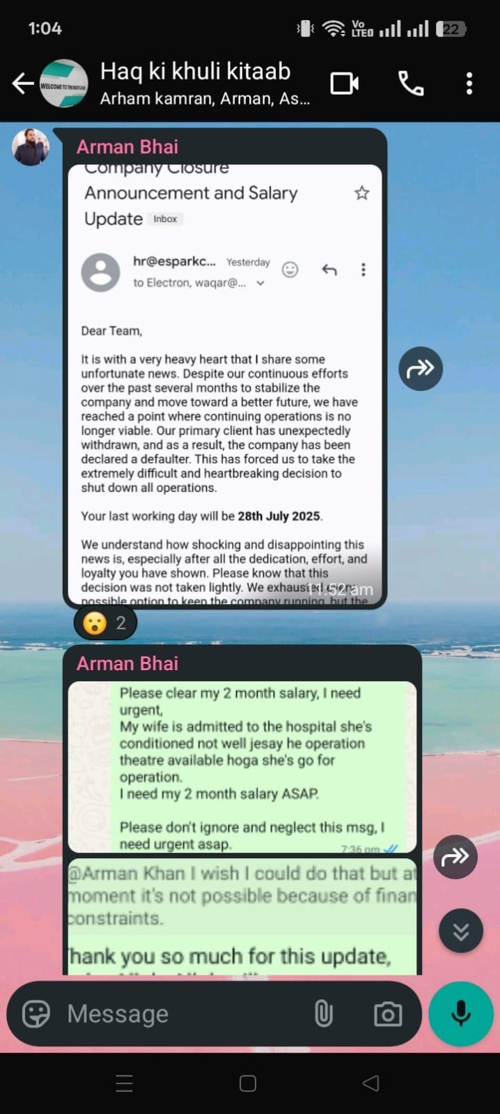

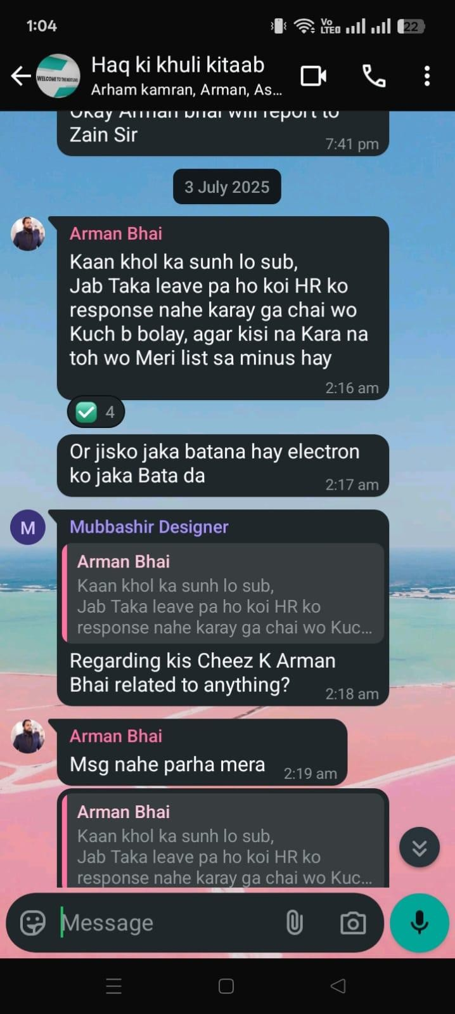

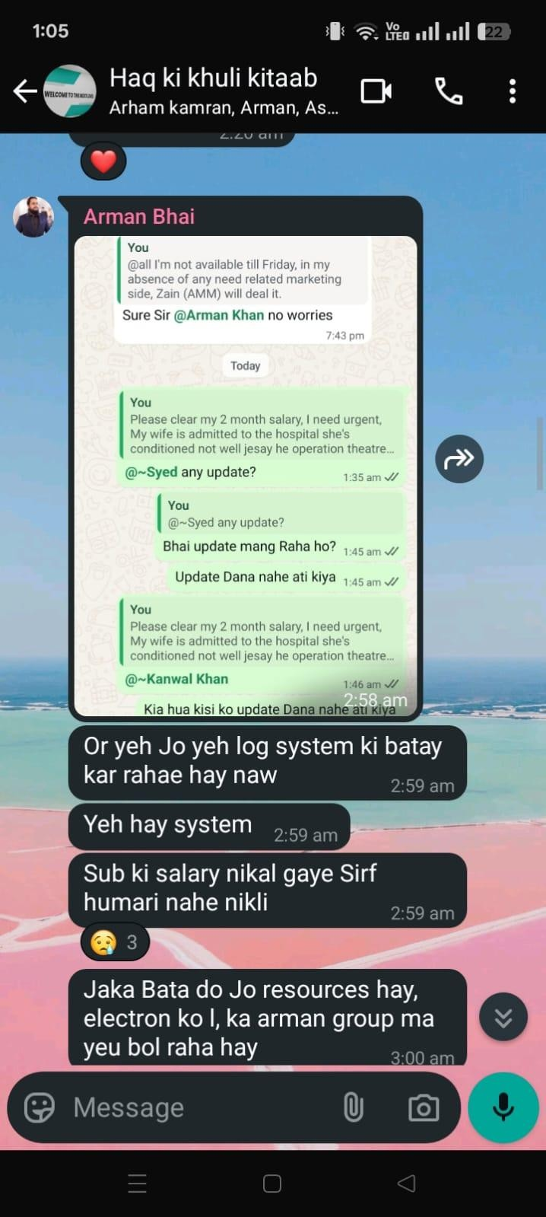

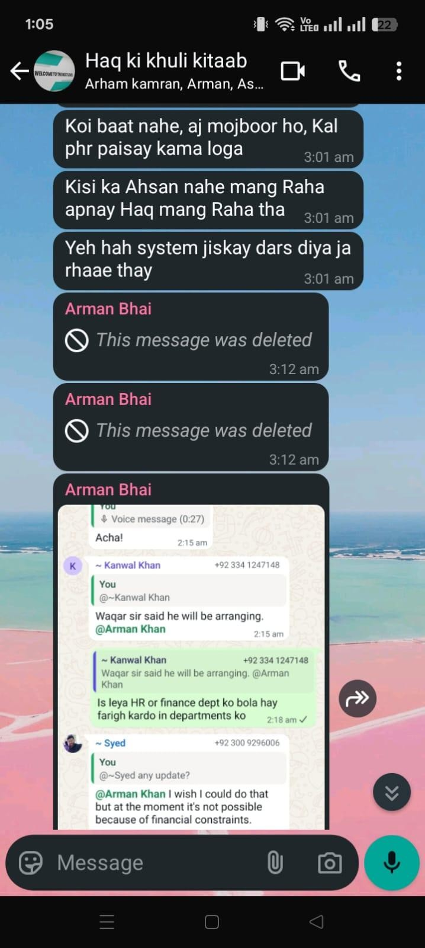

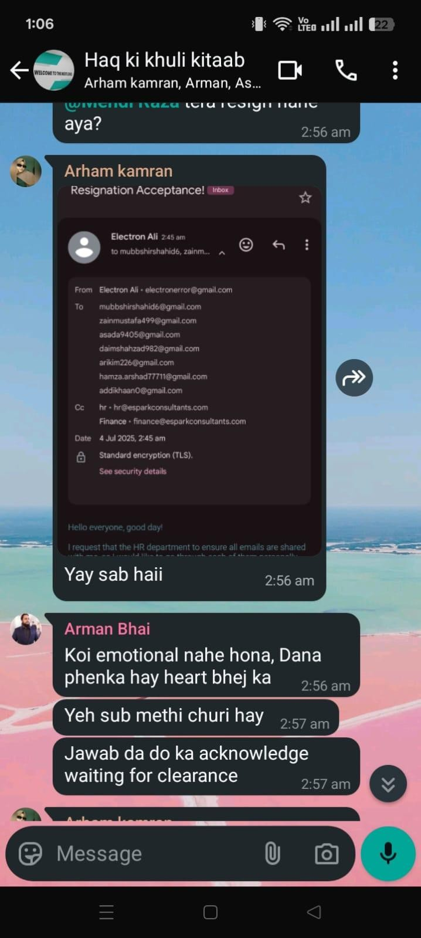

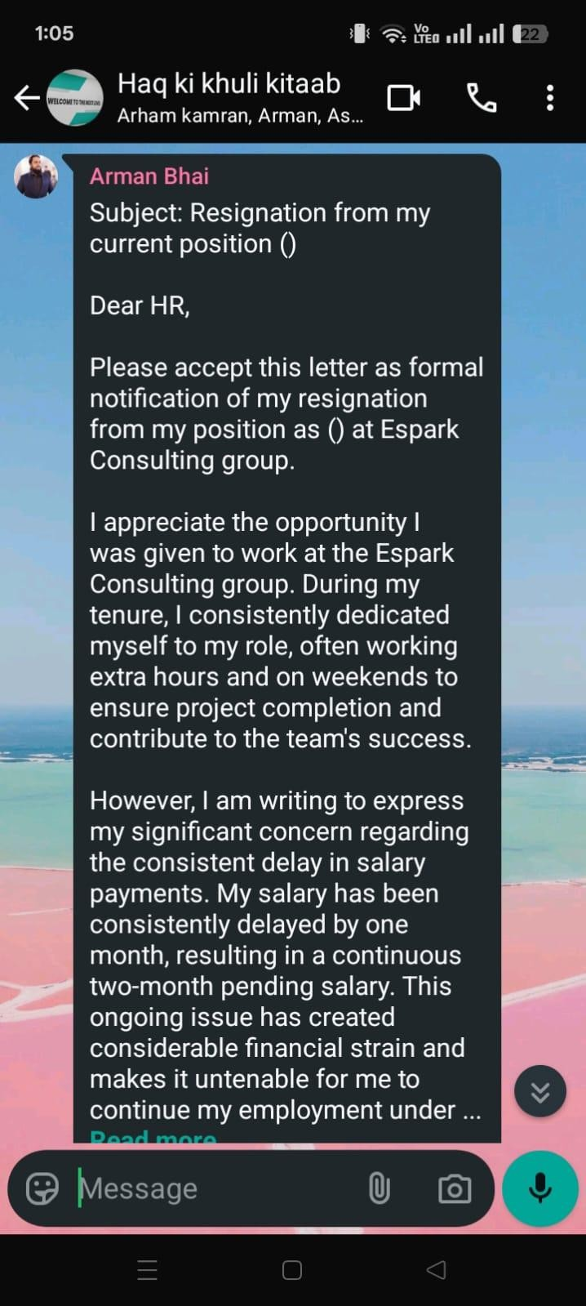

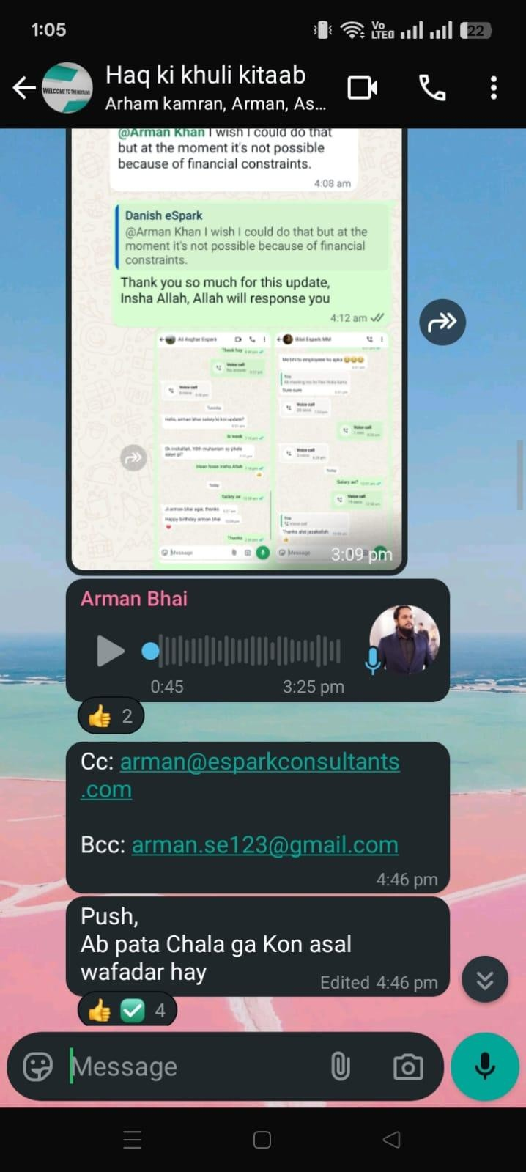

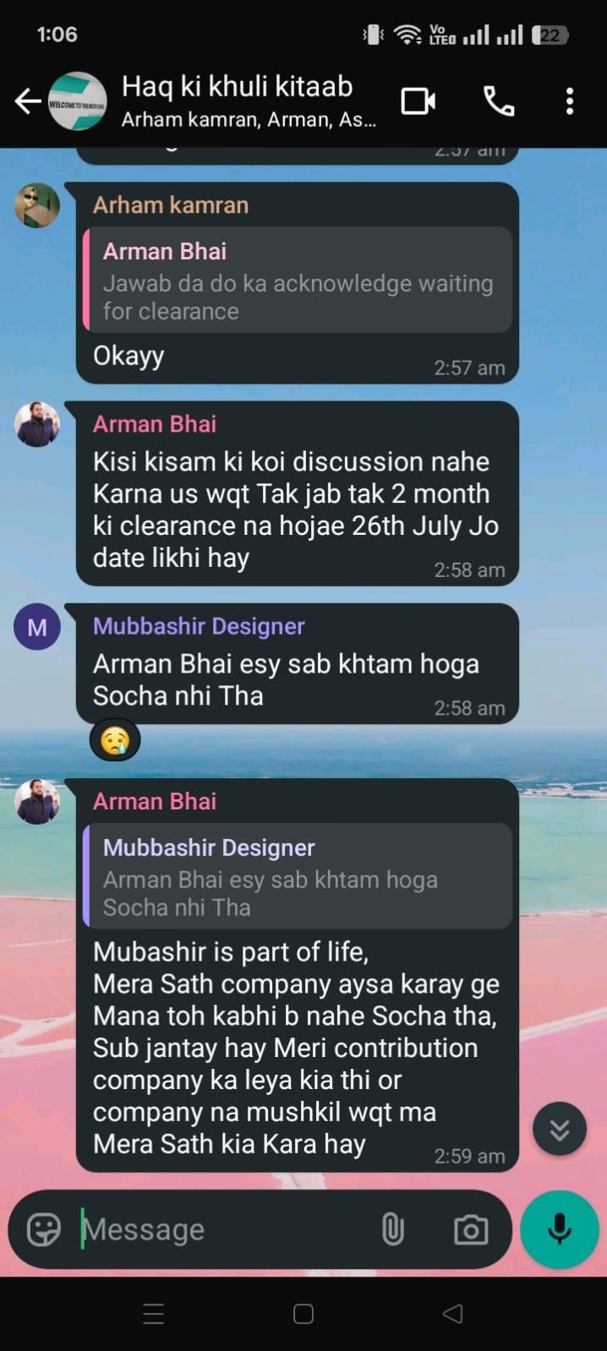

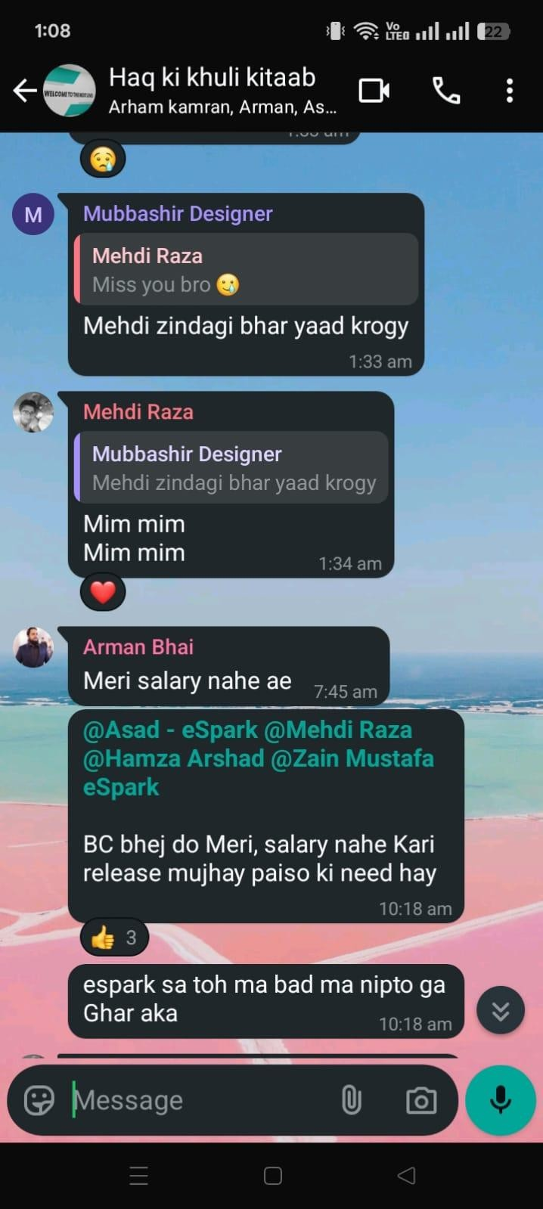

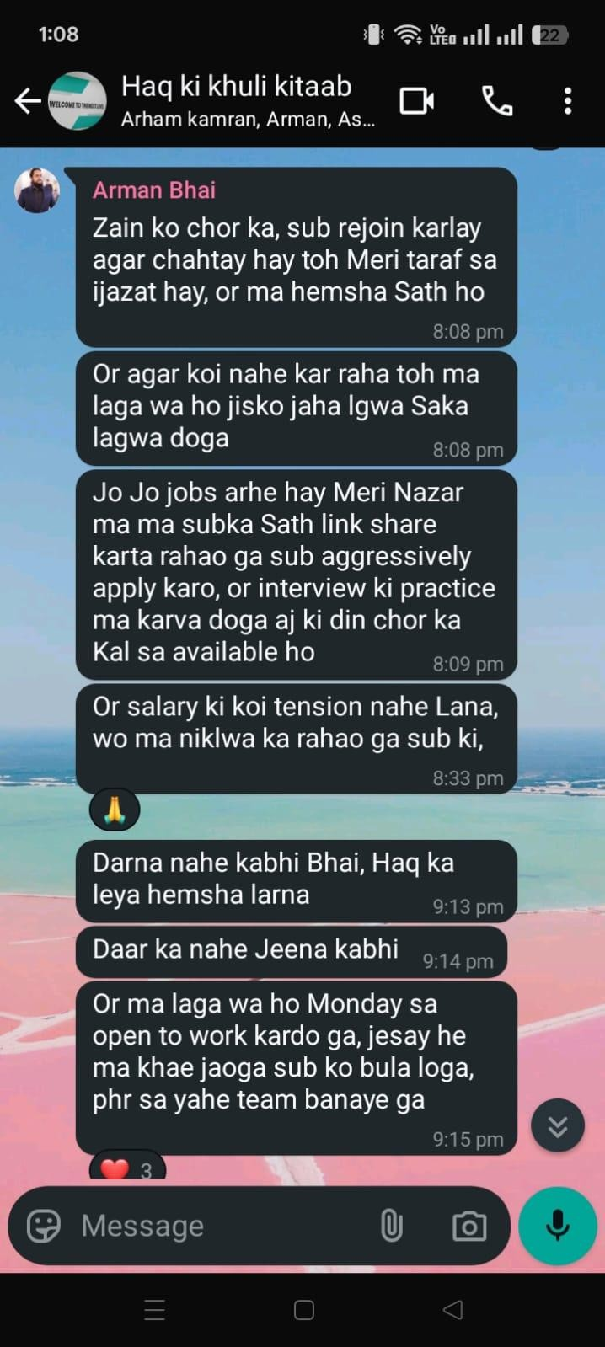

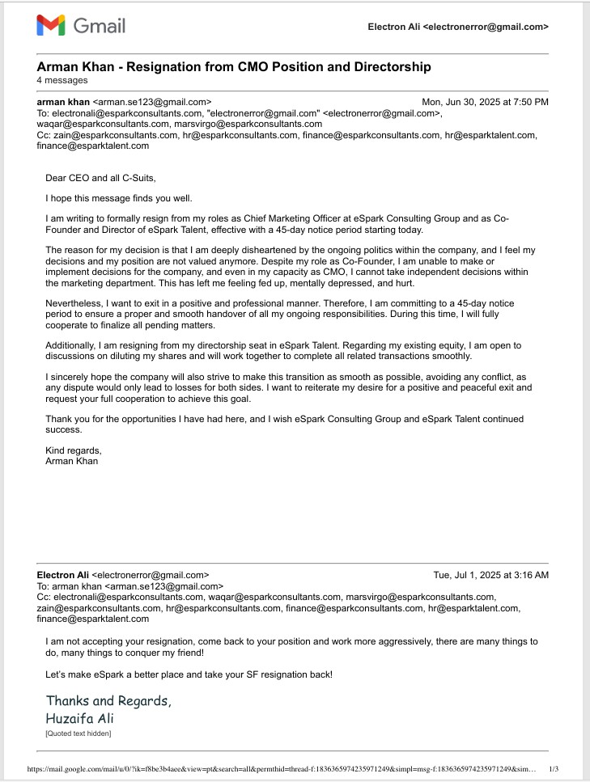

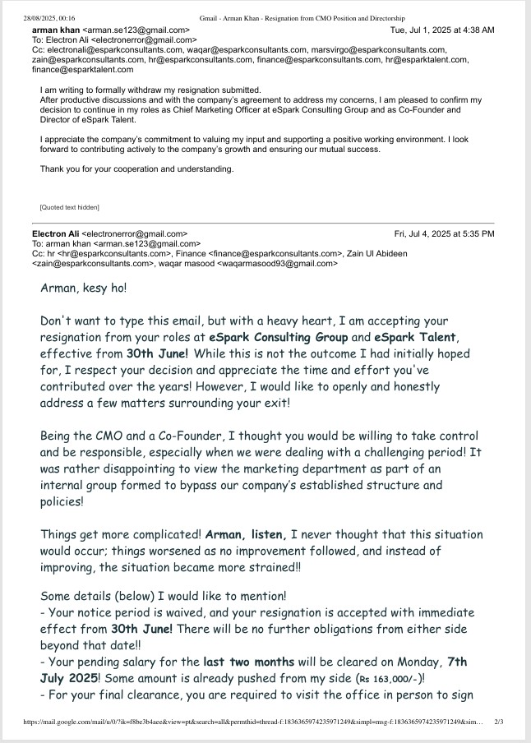

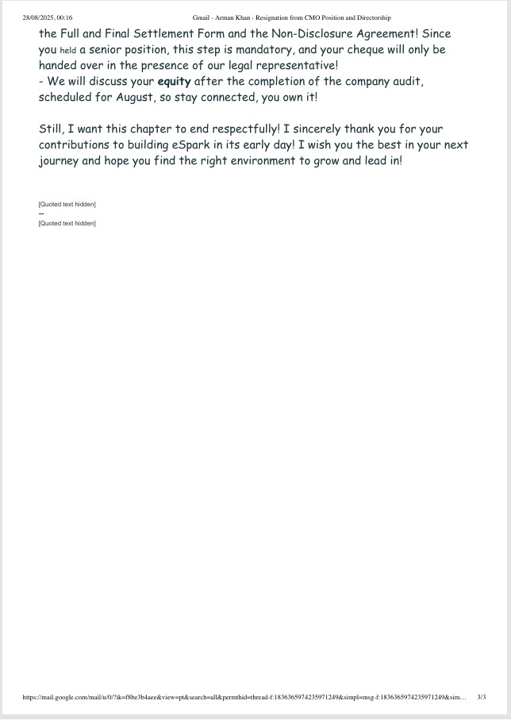

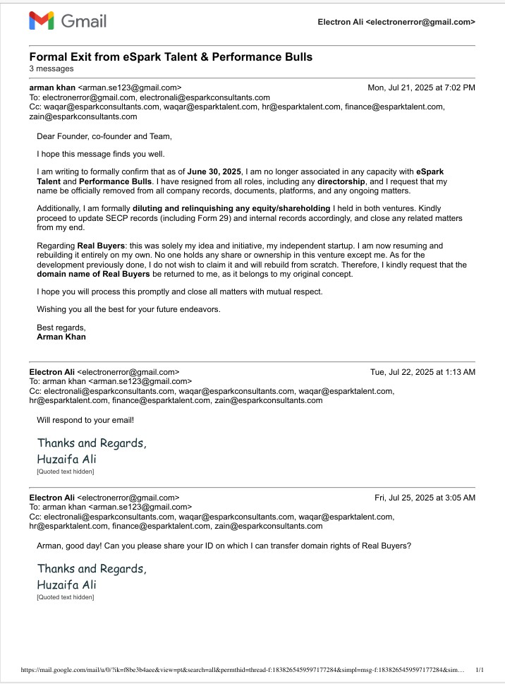

Annexure B: Screenshots – WhatsApp threats & misuse of confidential information.
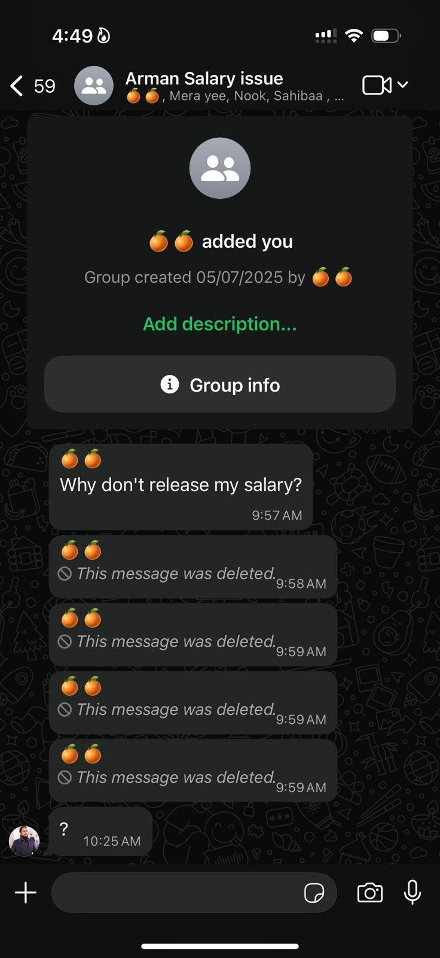

Annexure B: Screenshots – Bribery (Hamza Arshad case).

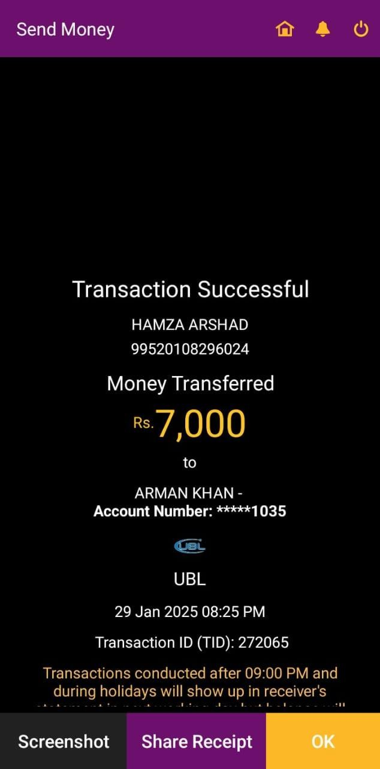
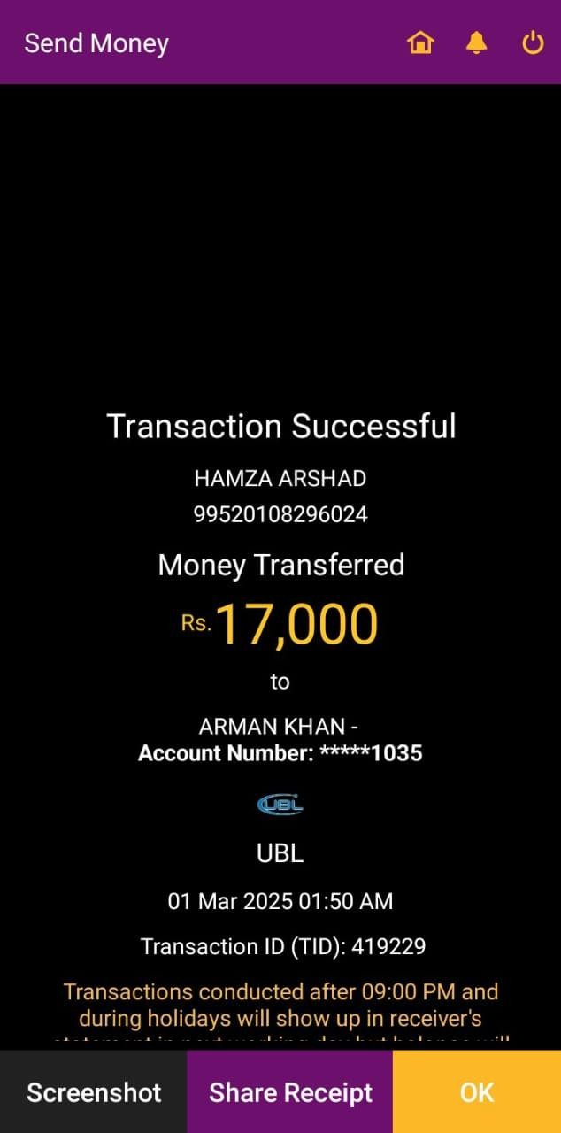

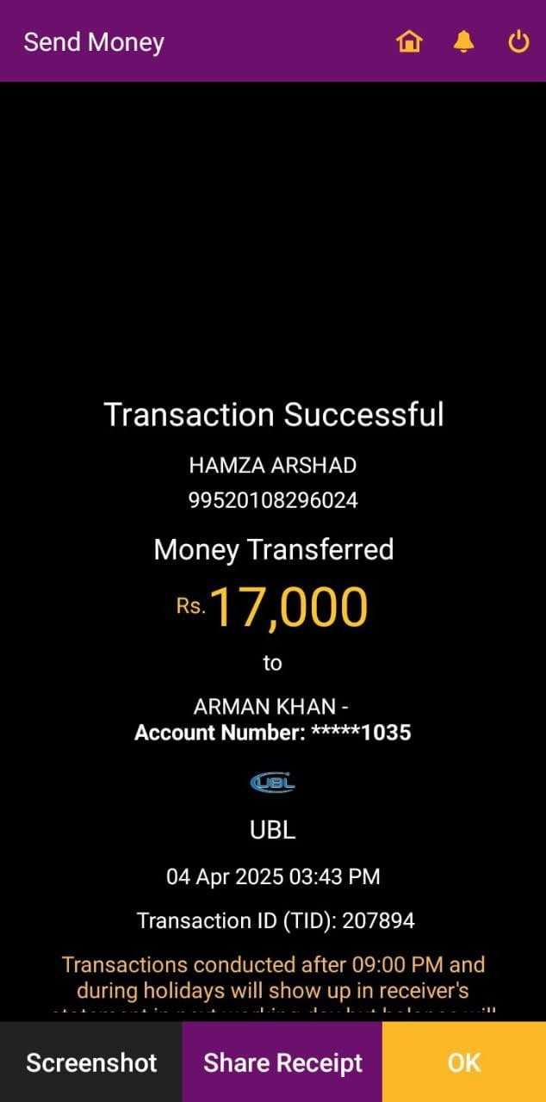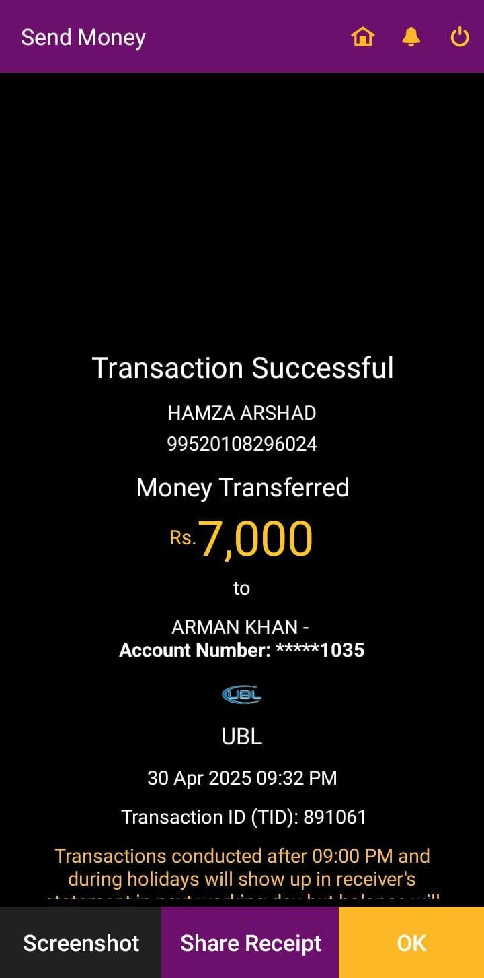

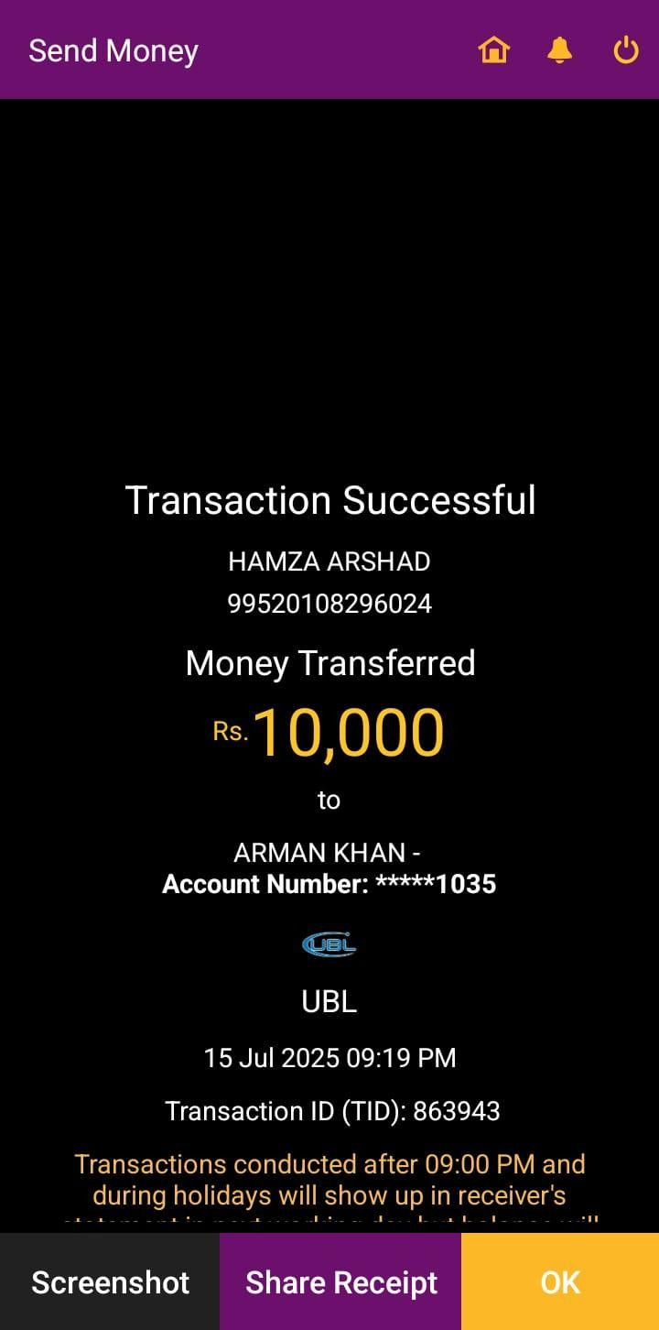

Annexure C: Emails – Defamation to eZLO officials.

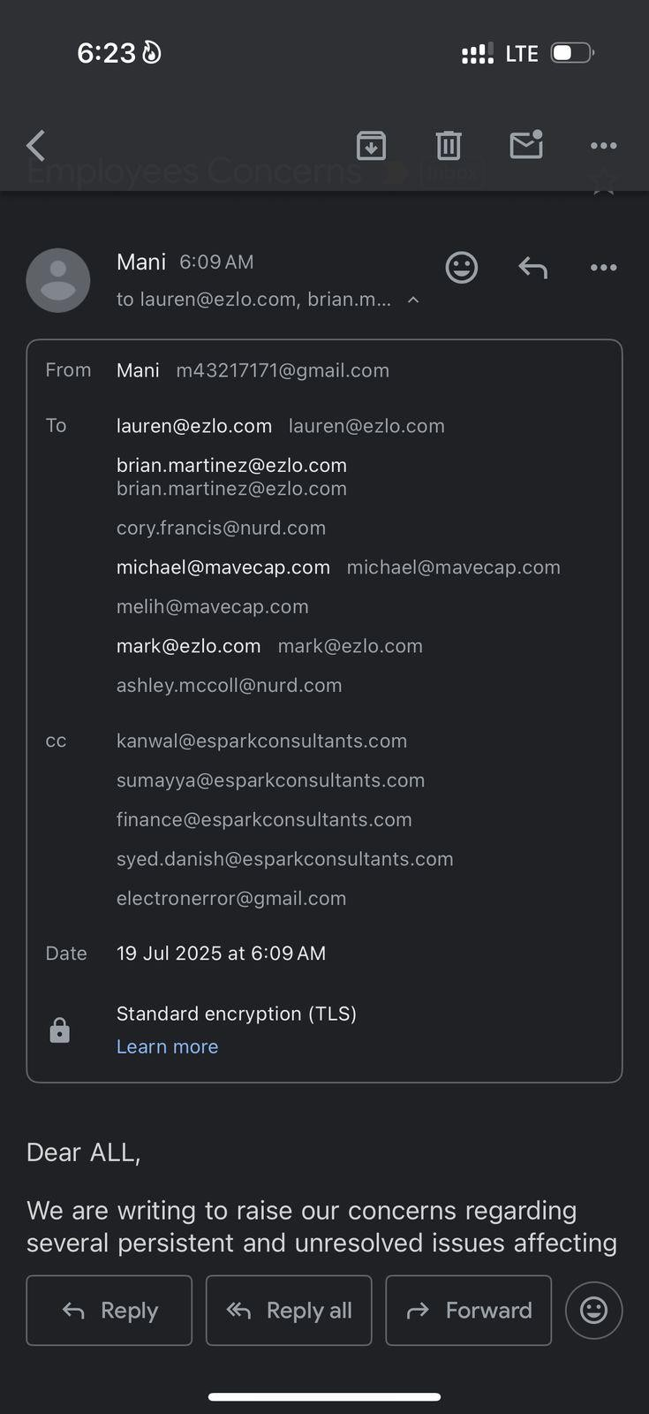

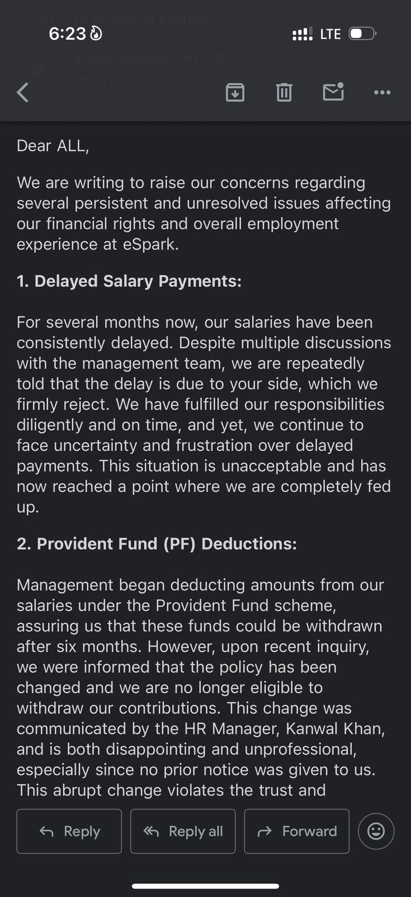

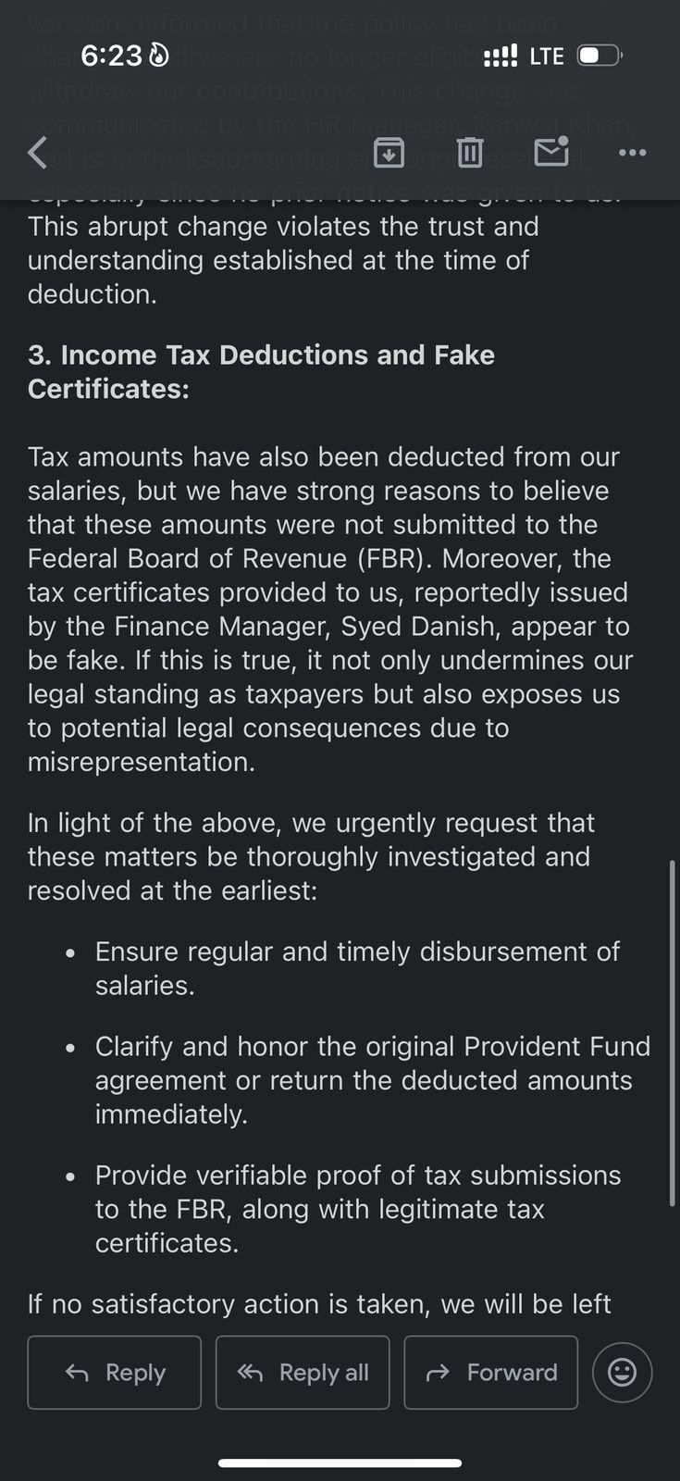

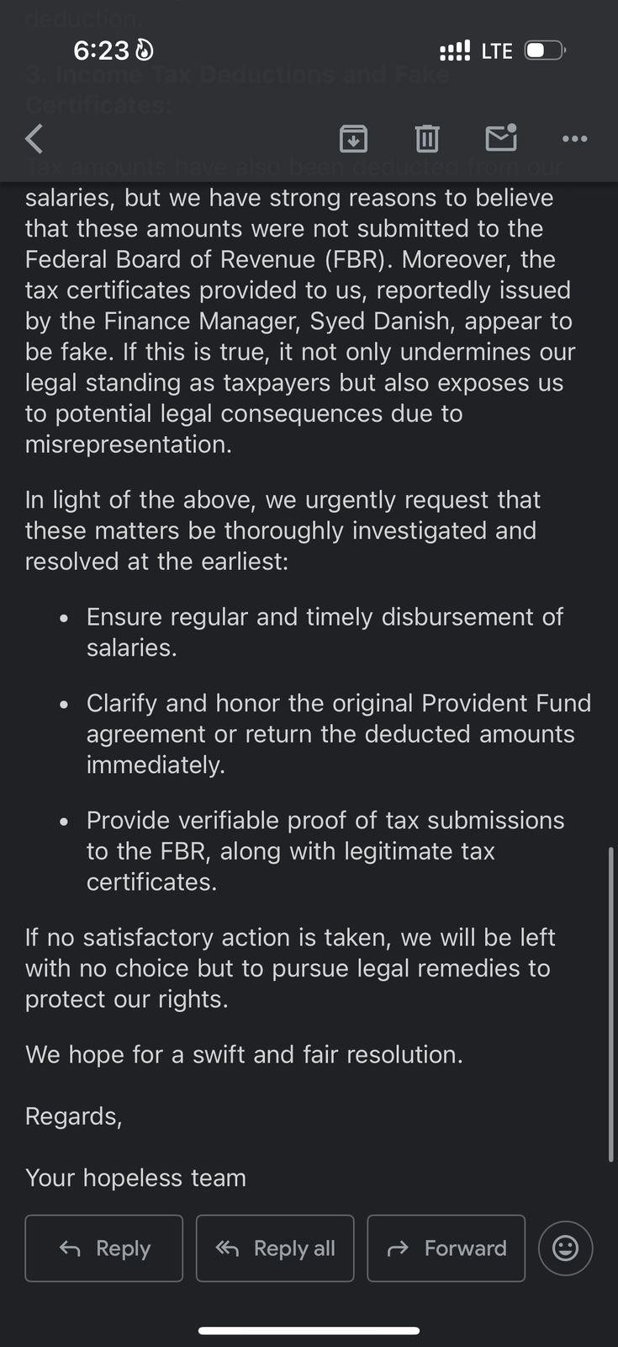

Annexure D: Screenshots – Unauthorized LinkedIn mi
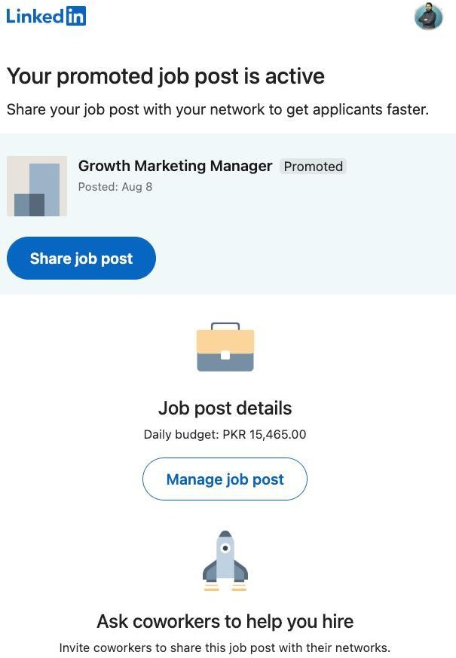

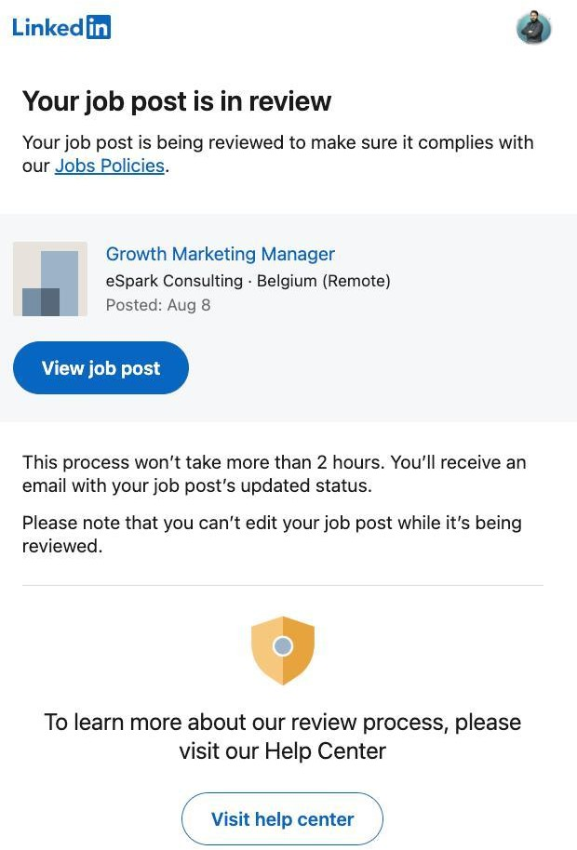

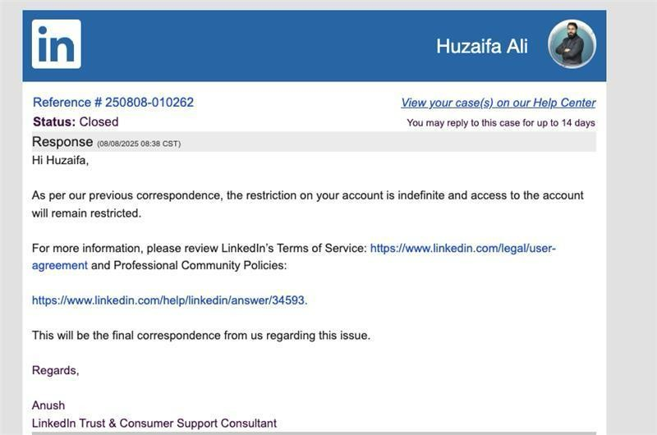

Annexure E: Video – Abusive remarks against Army Chief & management.

